Chosen Topic and Rationale

Our project will show US domestic flight airports/cities and flight paths with various additional interactive information (via buttons). Flight paths/cities can then be clickable with popup information.

* US Domestic Airline Flight Pathways
  + -revenue,
  + -fuel,
  + # of passengers,
  + -busiest route,
  + Busiest cities
  + -crashes?,
  + -crimes reported
  + no fly zones?
  + revenue lost on bad weather?
  + holidays?
  + delays/cancellation

Data Sources:

1. <https://www.bts.gov/newsroom/2017-traffic-data-us-airlines-and-foreign-airlines-us-flights>
2. <https://www.transtats.bts.gov/Data_Elements.aspx?Data=5>
3. <https://www.transtats.bts.gov/OT_Delay/OT_DelayCause1.asp?pn=1>
4. <https://data.world/ourairports/989444cc-447b-4030-a866-57fcd6c2d3ee>
5. <https://data.world/garyhoov/us-airline-route-segments-2015>
6. <https://data.world/datasets/aviation?page=3>

Visualization Inspiration:

1. <https://bl.ocks.org/bricof/ae5a33a5d68ee96682030611643495b9/e88d94074aab1c8f1548202f79f0b21a5ee7df6c> flight paths

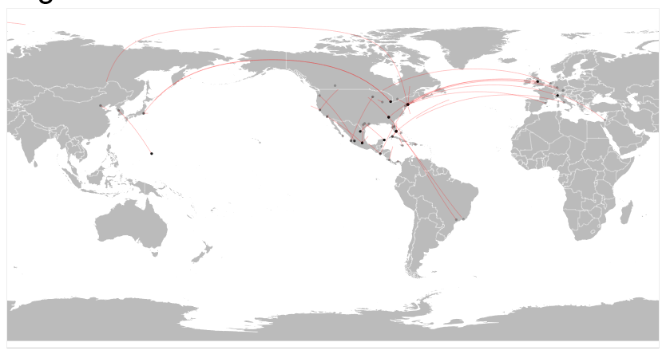

1. <http://bl.ocks.org/emeeks/a950399780ca90589f59> dots for cities

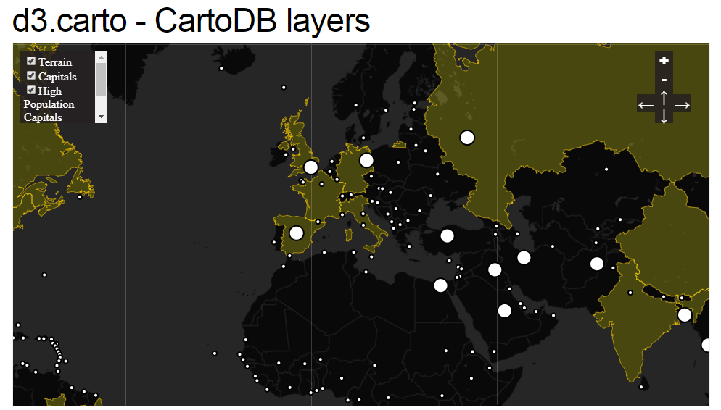

1. <https://github.com/upphiminn/d3.ForceBundle>
2. <https://bl.ocks.org/emeeks/912e24404b85a2af7dc7cb17927e816d>
3. <https://bl.ocks.org/emeeks/b57f4cc89dacd38fcdcd>

Github link: <https://github.com/Zleisure1/Project2_Visualization>